
Конспект

Відкритого Уроку
на тему:

“HAPPY MOTHER LANGUAGE DAY”

Розробка
вчителя англійської мови
Гусєвої Анни Юріївни

КОНСПЕКТ ВІДКРИТОГО УРОКУ З АНГЛІЙСЬКОЇ МОВИ
FORM: 1-В
DATE: 21.02.2019
TOPIC: HAPPY MOTHER LANGUAGE DAY
SUB-TOPIC: Numbers. Letters A-F. Birthday. Animals
LESSON TIME: 35 min. + 5 min. extension
AIM:
Практична:
- навчання спілкуванню англійською мовою;
- повторення літер A-F;
- повторення конструкцій: "What is this?", "This is ..."; “I have got …”
- вивчення конструкції “How old are you? – I am…”
- навчання кольорів та 1-10 англійською мовою;
- активізація ЛО з теми «Birthday».
Освітня:
- розширювати кругозір дітей та підвищувати рівень культури дітей;
- формувати навички говоріння, аудіювання;
- розвивати навички монологічного та діалогічного мовлення.
Виховна:
- формувати навички та вміння інтелектуальної праці.
Розвивальна:
- розвивати пізнавальний інтерес, пам'ять, увагу, творчі здібності дітей;
- розвивати інтелектуальну, емоційну мотиваційну сфери особистості людини.
COMPETENCES: subject, key (native & foreign speaking,
general cultural, social)
LEARNING OUTCOMES: ask/answer
MODELS OF INTERACTION: individual, grouping, pair work

PROCEDURE:
- WARMING-UP
- Greeting
    - T: Good morning, children! Smiling Sam and I are very glad and happy to see all of you today. Today we have an unusual English lesson. But before we start it, let’s make a circle, sing a “hello” song and share our good mood with each other.
(“Make a Circle” Song)
- Five Kittens’ Rules
    - T: Do you remember our Smart Kittens? They want to remember you our Classroom Rules: Listen! Be kind! Share! Work! (Be Smart!) Smile!
    - T: If you agree with all these rules, give me Five! But doing it, answer my question: “How are you?”

- INTRODUCTION

- “What’s a Matter, Smiling Sam?”
    - T: Children, do you know what holiday is it today? Today people all over the world celebrate International Mother Language Day. What is our Mother Language? Yes, it’s Ukrainian. And what about Smiling Sam? Yes, he speaks English.
    - T: But look at Sam? What’s the matter? Our friend is sad. Mr. English invited him to the party, but our Smiling Sam doesn’t have a present. Shall we help him? To make a present we should do different tasks. After doing each, we’ll get a piece of puzzle, and at the end of the lesson (when we have all the pieces), we’ll make a big present for Mr. English and Smiling Sam will be very glad!

- “Clap and Number” Game
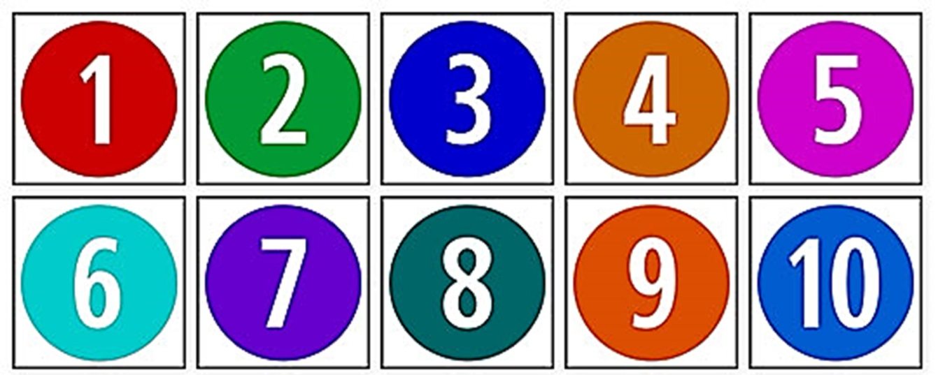
    - T: Let’s start our work with numbers. Look at the blackboard! Here you can see 1-10 numbers. Let’s Count! And now I’ll close some of numbers, you can’t name them, instead you must clap. Let’s Start!

- PRACTICE
- “Happy Birthday!” Game
    - T: What question we always ask, when we deal with numbers? Yes, it’s “How old are you?” question. Now I propose you to play a board game with our hot Monkey. Let’s divide into two groups (two kinds of Smileys). You should dice a cube and say how old he or she is. Let’s have Fun!

- Hot Monkey
    - T: And now let’s make a circle and play “Hot Monkey” game. You should ask and answer very quickly and throw a ball in chain.
- Banana Smoothie
    - T: Our Monkey ran, jumped and danced. And now it is very hungry! Let’s make some tasty Banana Smoothie for it!
(Banana - peel banana – cut banana - shake banana - drink banana – banana - no more!)
- Funny Letters’ Hide-and-Seek
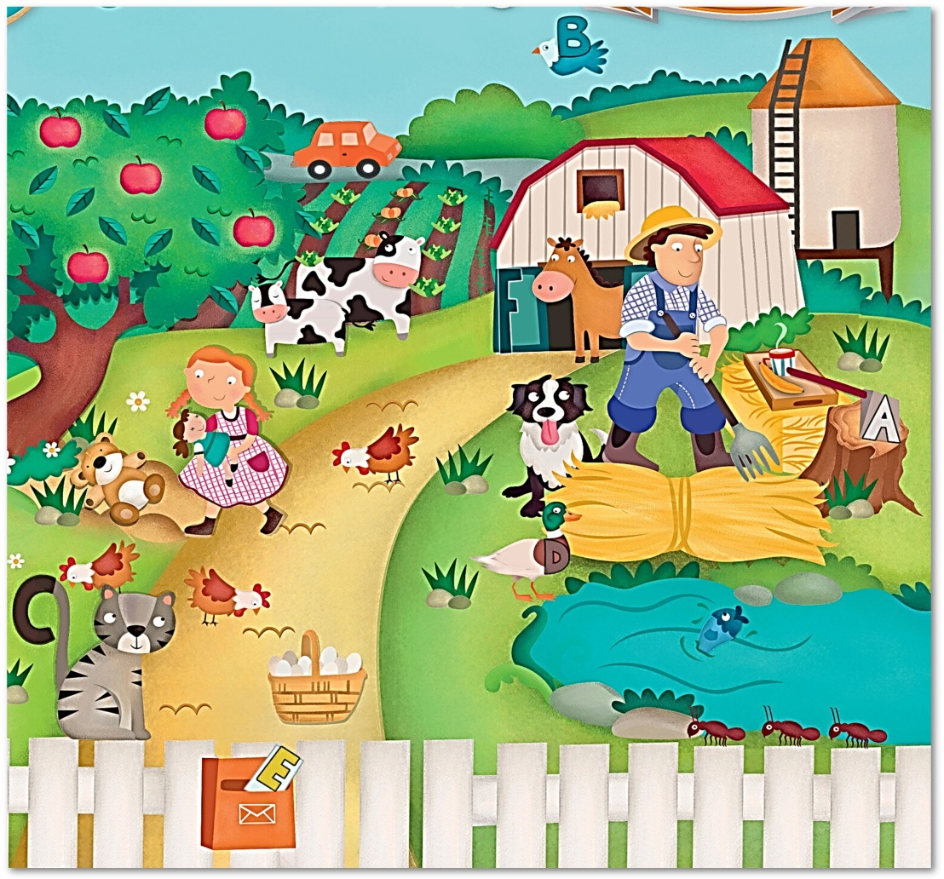
    - T: Are you hungry now? So let’s continue! Look at the blackboard, here we have a poster with letters. But they decided to play hide-and -seek with you. We must find all the letters and name the words beginning with each letter. Let’s start! Who can find the letter Aa?..
    - Writing in the Air

- Bingo “Find their Letters!”
    - T: And now let’s show how you can work in pairs. I propose you to play “Bingo!” Each pair gets a table with letters and a lot of cards with pictures. You should find the first letters to all words and divide them. Who’ll be ready should say “Bingo!” Don’t forget about team work.

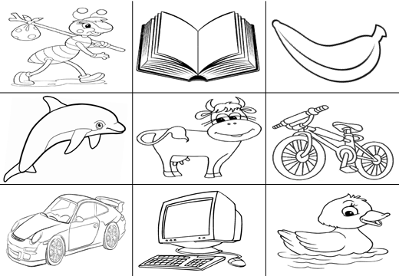
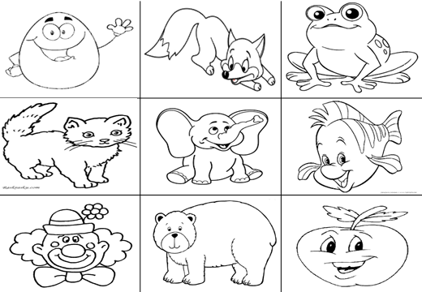
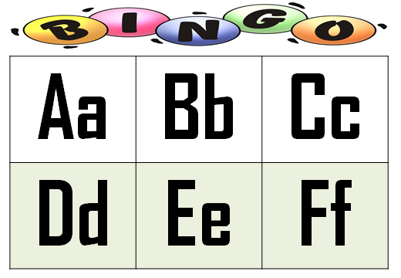
- CONSOLIDATION
- Make your Present!

    - T: So, we are ready with all tasks, we have got all pieces of the puzzle. Let’s help Smiling Sam and make a present!
    - And now I propose you to make your own presents for Mr. English. Let’s draw!

- Video “Happy!” (https://www.youtube.com/watch?v=PraN5ZoSjiY )
- Mood
- Relaxation

FEEDBACK/REFLECTION:

